**ABSTRACT**

This project outlines the design of a Home Automation System (HAS) that is both cost-effective and wireless. It focuses on developing an IoT-based system capable of controlling various home components via the internet. The project's goal is to create firmware for smart control, reducing human interaction and maintaining the integrity of all electrical devices in the home. We utilized NodeMCU, a popular open-source IoT platform, to automate processes. Different system components use various transmission modes to enable communication between the NodeMCU and the actual appliances. The primary control system employs wireless technology, allowing remote access via voice. Cloud server-based communication enhances practicality by providing unrestricted access to appliances, regardless of distance. A data transmission network strengthens automation, enabling control of electrical appliances and devices with a low-cost design, user-friendly interface, and easy installation. Appliance status and control are accessible on an Android platform. This system is designed to assist and support the needs of the elderly and disabled at home, while also improving the standard of living through smart home concepts. Smart irrigation systems are a new technology that uses sensors and weather data to optimize watering schedules for crops. These systems can save water and energy while also improving crop yields. Smart irrigation systems have the potential to transform agriculture by conserving water, enhancing crop yields, and boosting efficiency

**CHAPTER 1**

**INTRODUCTION**

Home automation means the automated and electronic control of household features, events, and applications. In simple terms, it permits us to easily manage your home's utilities and operates via the Internet, improving convenience and secure while also reducing household expenses. Home automation involves a system of interconnected, seamless devices that work together helps to improve the comfort of your house, personalized, efficient, and secure. The adoption of smart home systems is rapidly increasing because of their ease of use and extensive capabilities. By integrating speech recognition technology, these systems become more user-friendly and accessible. While some individuals seek home automation for convenience and luxury, Additionally, it offers significant help for people who are physically challenged or disabled, significantly enhancing their quality of life. [1].

The system consists of three essential components: sensors, controllers, and actuators. The continuous advancement of technology is a global achievement, primarily aimed at enhancing productivity while reducing labour requirements. The Internet -of-Things plays a vital role in this modern technological world, significantly impacting how we communicate with and control our home environments [2]. Home automation is characterized by the ability to remotely control devices via a mobile application or a voice assistant. This technology allows gadgets to communicate with one another, eliminating the need for manual control. Home automation enhances quality of life, reduces component and power costs, and increases safety through the use of security cameras and systems. Every appliance may be viewed and operated remotely through software interfaces such as web apps or Android, resulting in a home environment that is both highly manageable and accessible [3].

Voice-automated systems are highly advantage for automation and aiding paraplegic individuals who cannot use remotes or other means of control. They are very beneficial to those who are blind individuals since traditional remote-controlled home appliance systems use IR remotes, which require direct line-of-sight to the appliances. Voice command systems are user-friendly and can be operated by illiterate persons by simply mentioning the device name and saying “ON” or “OFF”. These are very robust and can be integrated with mobile phones, allowing operation via Wi-Fi from anywhere. While Bluetooth or Wi-Fi-based remote control systems are efficient, they typically restrict operation to registered smartphones. Voice-automated systems overcome this limitation, making the system accessible to everyone. [4]

In a Building Automation System, buildings can be equipped with IoT-enabled devices. Older homes can be transformed into smart homes with minimal investments. Modern smart homes often utilize technologies such as LTE, 4G, 5G, or Wi-Fi for connectivity [5]. Voice recognition has emerged as a key component of machine interaction, enabling users to issue specific commands that are processed by speech recognition algorithms and programs. When properly calibrated, home automation systems can be extended to companies, allowing for the control of lights and other appliances. The calibration and settings for automation can vary significantly depending on the application. Engineers utilize advanced calibrations and algorithms to meet specific requirements. Automation is essential for building smart cities, as it plays a role in various operations such as monitoring water, sewage, and traffic. A smart home system integrates metering for light, moisture, and other factors, along with security management and appliance control [6].

The Internet-of-Things (IoT) is gaining immense significance in our modern world, leading to substantially greater efficiency while reducing the amount of labour required. By leveraging IoT, we have successfully managed appliances across various domains, including home automation, using the Node Microcontroller. Other boards like Raspberry Pi and Beagle Bone can also be utilized. Voice communication is the most efficient mode available in today's technology, as it allows for tasks to be performed through simple voice commands [5]. The primary goal of home automation is to address the limitations of traditional home security systems by providing real-time information about the current status of the home when the owner is away. Additionally, it aims to enhance the network security of IoT devices through the encryption and decryption of user data [7].

The intelligent personal assistant (IPS) can perform a variety of tasks based on user input, such as providing geolocation information, daily news updates, and social media account notifications. Additionally, it can send notifications for commonly used apps. These IPS are highly user-friendly and help reduce workload, making them beneficial even for those without formal education. In recent years, the popularity of mobile technology has significantly surged. [8]

**1.1 Smart Home Technology Examples**

Every aspect of daily life where technology is now incorporated into the home, there is a smart home alternative available. This includes smart versions of lightbulbs, dishwashers, and various other appliances.

1. Smart Televisions: These TVs include an internet connection so they can use apps to access content like music and video on demand. Additionally, some smart TVs have gesture or voice recognition. [13]
2. Intelligent lighting setup: Smart lighting systems have the ability to be modified and controlled remotely. They can also sense when people are in the room and change the lighting accordingly. Moreover, self-regulating smart lightbulbs are capable of adjusting to daylight availability. [13]
3. Intelligent heating systems: With built-in Wi-Fi, smart thermostats like Google Nest allow customers to remotely monitor, schedule, and adjust the temperature of their homes. In order to maximize comfort and efficiency, these systems also automatically modify the settings based on homeowners' behaviour. Futhermore to reporting energy usage, smart thermostats can remind customers to replace their filters. [13]
4. Garage door openers and smart door lock: Smart locks and garage door openers allow homeowners to choose who may enter their home and who cannot. Additionally, smart locks are able to recognize when residents are around and open the doors for them. [13]
5. Intelligent security systems and cameras: Smart doorbells and security cameras, like Ring, allow homeowners be aware of their properties even when they're not home. [13]
6. Prudent lawn and pet care: Connected feeders enable automatic pet care. Connected timers can be used to water lawns and houseplants. [13]
7. Intelligent appliances for the kitchen: Smart kitchen appliances come in a variety of styles from companies including LG, GE, and Samsung. These appliances include toasters and slow cookers; washing machines and dryers in the laundry room; refrigerators with smart features that can create shopping lists, brew fresh coffee automatically at predetermined times; and refrigerators with smart features that can keep track of expiration dates. [13]
8. Intelligent home surveillance systems: For instance, household system monitors can detect a power spike and shut off appliances, detect water leaks or frozen pipes and turn off the water to prevent flooding in the house. [13]

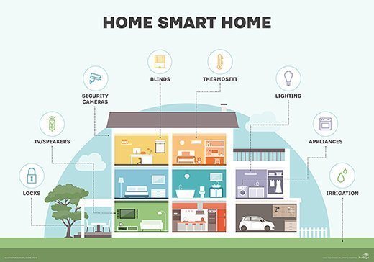

**Figure 1.1. Smart home technologies**

**1.2 Benefits of a smart house**

1. **Provides Comfort**: Remote home monitoring enables homeowners to mitigate risks such as an unlocked front door or a coffee maker left on. [13]
2. **Takes user preferences into account for ease of usage**: Users can set up their garage door to open, lights to turn on, fireplace to light, and preferred music to play when they get home, among other automated functions. provides comfort. Seniors can safely stay at home longer rather than transferring into an assisted living facility because to Internet of Things (IoT) gadgets, which allow family members or caregivers to remotely monitor the health and well-being of seniors. [13]
3. **Increases effectiveness:** A smart home system could have the ability to identify the homeowner's habits and modify the air conditioning system as necessary. [13]
4. **Saves money and resources**: With a smart irrigation system, the lawn receives the exact amount of watering it needs. By using home automation devices and smart systems, resources such as energy and water are utilized more efficiently, leading to conservation of natural resources and cost savings for the customer. [13]
5. **Manages the work**: Intelligent virtual assistants, like Google Home or Amazon Echo, are capable of completing tasks via voice commands and speech recognition. For example, voice instructions are used by homeowners to activate their smart gadgets, search the internet, and switch on music. [13]

**1.3 Disadvantages of a smart home**

1. **Requires an accurate internet connection:** The devices and gadgets connected to a smart home may become dysfunctional due to an unstable internet connection or a network outage. [13]
2. **Perceived difficulty:** Some people struggle with technology, or they are impatient. Manufacturers and alliances of smart homes are striving to make their products easier to use and more advantageous for users of all technical skill levels by simplifying their design and improving the experience for users. [13]
3. **Absence of guidelines:** For home automation systems to be truly effective, devices must either use the same protocol or be compatible with each other, regardless of the manufacturer. As home automation is still an emerging field, there is no universal standard yet. However, to ensure compatibility and a seamless user experience, standard alliances are working with manufacturers and protocols to establish consistent guidelines. [13]
4. **Insufficient privacy of data:** Data privacy is a significant concern for many discerning homeowners. According to research by Parks Associates, around 72% of consumer’s express fear or strong concern about the security of the personal information collected and transmitted by smart home devices. They also worry about the risk of unauthorized access or control of these devices. While smart home platform and device manufacturers collect user data to personalize their services and offer new, improved features, those seeking to grow their customer base must prioritize transparency and build trust. [13]

**CHAPTER 2**

**LITERATURE SURVEY**

**2.1 LITERATURE OVERVIEW**

1. **Mohammed Hayyan Alsibai, Waheb A. Jabbar, Nur Syaira S. Arman, and Samiah K. Mahayadin “Design & Implementation of I-o-T-based automation system for smart home” [2018].** This research project has proposed, designed, and fabricated a low-cost Wi-Fi-based automation system for home prototype using Arduino Uno and a smartphone. This system allows easy and efficient control of all electrical appliances, such as lights and fans, via Wi-Fi. The sensors monitor motion, humidity, and temperature in the house, and a buzzer activates when motion is detected. The Smart Home Automation System offers comfort, intelligence, enhanced security, and an improved quality of life. Additionally, it can help reduce electric bills, as users can control the electrical appliances remotely without expending human energy. [6]
2. **Tushar Chaurasia, Prashant Kumar Jain, “Enhanced Smart home automation System based on Internet of Things”- (2019)**. This paper presents the development of a smart home system designed to enhance security and comfort. The suggested framework improves automation services and security while reducing computational overhead. Future updates will provide even more secure mechanisms and improved smart home features. The system eliminates the essential for a gateway by using cloud storage and processing for intermediate data, thereby reducing costs. Compared to Bluetooth, voice, and ZigBee-based systems, our IoT-enabled smart home system offers greater security and automation. [5]
3. **Shradha Somani, Parikshit Solunke, Shaunak Oke Parth Medhi - “IoT Based Smart Security and Home Automation”. [2019].** The primary goal of our project is to utilize an Android smartphone for convenient control of home appliances, while also ensuring robust home security and safety. Future enhancements of the system could include integrating a voice call feature within the smartphone app, allowing users to control appliances via calls. Additionally, advanced login technologies like retina or fingerprint scanning could be implemented. To further enhance security, we could incorporate image processing to improve accuracy, using a trusted face database to differentiate between actual intruders and false alarms. [7]
4. **Kabita Agarwal , Arun Agarwal, Gourav Misar :-“Review and Performance Analysis on Wireless Smart Home Automation using IoT” [2019].** Certainly, IoT is a cornerstone of modern home automation, providing convenience for everyone and particularly aiding individuals with disabilities. In this project, we developed an IoTbased home automation model using the Arduino ESP8266 controller board with an integrated wireless module. An HTML page was designed for appliance control, and embedded C Programming was utilized for software development. The project's main objective is on enhancing safety and security within a smart home environment. By the use of servers, home automation technologies offer automation and remote control from any location. It promotes energy efficiency, electricity savings, and empowers disabled individuals to manage their homes effectively. Connecting the system to a nodeMCU(Wi-Fi) module enables control of the system from several devices at once, improving accessibility compared to Bluetooth with limited range and device connections. This automation reduces unnecessary human effort, enhances living standards, and contributes to a simpler, more comfortable life for society as a whole. [5]
5. **Ambuj Kumar, Danish Ather, Rani Astya, Danila Parygin, Amit Garg, Dharm Raj: - “Analysis of Environmental Factors for Smart Farming: An IoT Based Approach” [2021].** This system analyses and provides alerts based on environmental factors such as temperature, humidity, and soil moisture. One of its key advantages is the ability to adjust its behaviour according to changing conditions like weather and soil characteristics. This approach can be applied to irrigate various areas including agriculture, horticulture, parks, gardens, and golf courses. Compared to other automation systems, this approach works better and is more economical. High-sensitivity sensors can be utilized for large agricultural areas in extensive applications. Monitoring efforts should encompass not only agricultural output and productivity but also natural resource management. [7]
6. **Harshavardham Reddy, Neerav Negi, Zeenia Gupta, Sagar Sood, Ishika Kansal, Nikhil Aggarwal - “Advanced IOT $Home Automation Using Google Assistant and ThingSpeak IOT Platform”- [2022].** The experimentally proven effectiveness of IoT-based home automation is evident in its successful control of simple appliances from anywhere globally through the internet. This developed system not only monitors various sensor data such as temperature, gas levels, light intensity, and motion but also executes actions like turning on lights based on ambient conditions. It stores sensor parameters in the cloud and sends notifications via email or SMS as required, allowing users to assess home metrics from any location. IoT-based homes offer multiple services like smart houses or machine-driven homes, enhancing individuals' quality of life. This project aims to control household devices through an app using IoT technology. IoT continues to introduce new technological advancements into our daily routines, simplifying and enhancing our lives. [2]
7. **Raj kumar, K. suresh, Boobalan.M, M. Gokul, G. Darun Kumar, Archana.R: - “IoT Based Voice Assistant using Raspberry Pi and Natural Language Processing” [2022].** In this study we use the Raspberry Pi as the processor piece and fundamental construction of a personal assistant. It stresses the replacement of digital communication with ambient skills like robotics and the Internet-of- Things, which means the user interface is built into the actual device. The primary objective of this project is to use a Raspberry Pi and Google Assistant to build an Internet-of-Things voice control multilingual smart home automation system. Regardless of language, the user will be able to control a home. The Raspberry Pi, IoT devices, and this will be made possible by components. With the development of technology, especially IoT devices, smart gadgets, and home automation are rising. Future engineering students should be familiar with the basics of IoT devices. [8]
8. **Raj Kumar, Sugunesh.R, Risheka.S- “Voice-Activated Wireless Control System for Home Automation Using 2.4ghz Wi-Fi” [2022].** This paper aims to provide independence to elderly and physically impaired individuals during emergencies, offering a reliable wireless connection via IR remote control, Bluetooth, Wi-Fi, Alexa (voice-based speech recognition), and a mobile application. Our solution is designed to work seamlessly without the need to modify existing electrical wiring in the customer's home, simplifying the installation process. We offer a select number of controls to manage appliances according to the customer's preferences. This system offers several advantages over wired networks It serves people of all demographics but is especially advantageous for the elderly and disabled because of its automation and user-friendliness. The smartphone application manages the system without requiring additional training, and Its settings are customizable to suit personal preferences.Operating the system is straightforward, and it offers Android software capabilities to manage home appliances efficiently, saving time, being convenient, and easy to set up.[3]
9. **Tushar Rathore D.K , G. Gupta, Dr. Neeraj Kumar: - “Smart Irrigation system using IoT” [2023].** The system uses sensors to monitor soil moisture levels and adjust the water supply to ensure the plants receive the correct amount of moisture. These sensors were calibrated using reference equipment, and any values significantly different from the reference were corrected. We employed the most cost-effective IoT equipment to maintain the system's affordability. with the entire setup costing less than Rs. 1000. In smart irrigation system, data was collected at five-minute intervals over a period of three days to accurately track soil moisture levels. This data provided valuable insights into the moisture requirements of the wheat crop, enabling informed irrigation decisions. By continuously monitoring soil moisture levels, we ensured that the wheat crop received the exact amount of water required, leading to enhanced crop yields. [5]
10. **Ajmeer kiran, G.R. Sakthidharan, D. Divya priya, K. Prem Kumar: - “voice controlled home automation system using Google Assistants” [2023].** This paper explores the use of augmented reality (AR) for taxpayers in automating everyday electronics such as fans, rope lights, and air conditioners. Our research indicates that AR is the simplest method for achieving automation. The program features a user-friendly interface, making it accessible even to less educated groups. This AR method can be employed to manage and track energy consumption in everyday life, prevent dangerous situations, and is applicable for industrial and facility maintenance. Given the need for real-time access to systems from anywhere, our proposed model is an excellent candidate. Our goal is to create an even more sophisticated Industrial Internet of Things system in the future. By utilizing smart sensors and actuators, we can enhance industrial productivity, aligning with the industry 4.0 concept. IIoT leverages the capabilities of intelligent machines and real-time data to optimize the performance of longstanding industrial equipment. The objective is for smart AR devices to surpass human capabilities in information analysis, envisioning a fully automated world through AR. [2]
    1. **EXISTING SYSTEM**

One of the main challenges with existing Home Automation Systems (HAS) is their high implementation and maintenance costs, making them unaffordable for many users. additionally, many current systems require users to access a web application to view and control their homes, which can be inconvenient as it necessitates web access each time. Moreover, some HAS lack user-friendly interfaces for monitoring and controlling appliances. There are also limitations in the communication technologies used in existing automation systems. For instance, Bluetooth has a limited communication range of 10 meters, beyond which the connection is lost, preventing users from controlling home appliances. ZigBee, designed for low-rate wireless personal area networks, offers a data rate of 250 Kb/s, which is often insufficient. GSM, while providing global access, is costly and has a low data transmission rate with limited coverage in rural areas. [2]

**2.2.1** **RESEARCH GAP**

In traditional systems, operating electrical appliances remotely is not possible. It can be challenging for elderly and disabled individuals to manually operate switches. To address these disadvantages, we use voice instructions to control and monitor the various gadgets through Alexa over Wi-Fi. [3]

**2.3 PROPOSED SYSTEM**

The proposed solution eliminates the complexities associated with wired automation, including potential power supply issues. It offers a greater operating range compared to Bluetooth. The current design does not allow the monitoring and control of appliances remotely. However, the proposed Wi-Fi-based automation system enables to control and monitoring of various devices remotely. The system allows for remote control of all electronic appliances. [7]

The rapid rise in popularity of IoT applications in the 21st century can be credited to the widespread availability of the internet, advancements in mobile device technologies, and improved mobile communication methods. The proposed system, spoken instructions are provided to the Alexa device and voice commands have been integrated into Alexa via the Alexa app, and the Alexa account must be connected to the system. In this home automation scenario, the user issues commands to Alexa to control home appliances such as light bulbs, fans, and motors. The relays function according to the decoded commands that are obtained from Alexa. These commands are forwarded to the NodeMCU after decoding. [7]

The apparatus linked to the relevant relay responds to the user's request by turning on or off. Communication between the application and the NodeMCU (ESP8266) microcontroller is facilitated via Wi-Fi. As a result, the system addresses a various issue, including cost, flexibility, and security. Additionally, it provides benefits such as reduced energy bills and improved home safety. It is user-friendly and enhances the overall comfort of the home. [7]

The project introduces the idea of "smart homes" capable of handling a variety of home automation technologies. Each node's microcontroller is used to link the sensor circuits to the house, allowing for effective and thoughtful home automation. [7]

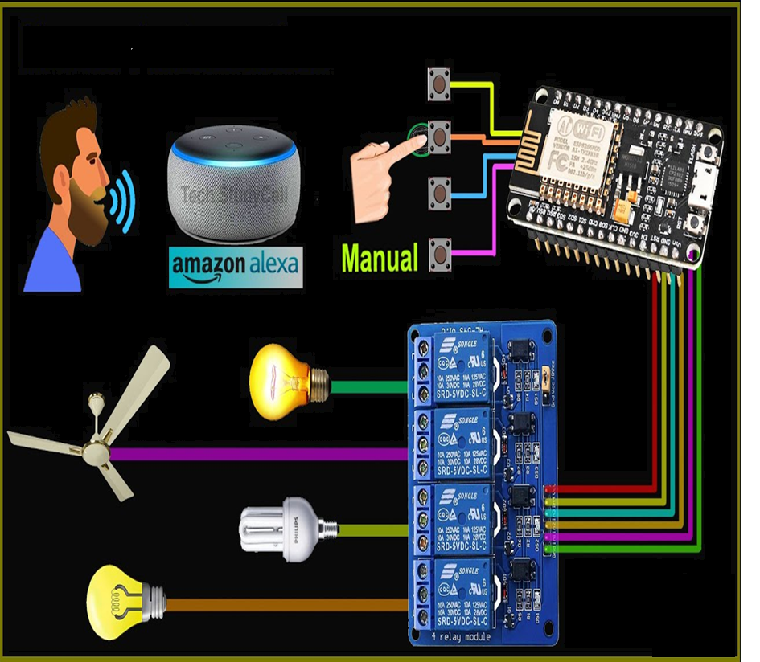

**Figure 2.3. Proposed System**

**2.3.1 PROBLEM STATEMENT**

Adopting standard home automation systems can be challenging for the average household due to their complexity and cost. Furthermore, a lot of these systems are not remotely accessible, which makes it difficult to keep track on and manage household equipment when you're not at home. The suggested Internet of Things (IoT) based home automation system is made to address these problems by offering a cost-effective and easy-to-use solution that can be accessed via an Alexa device and smartphone application from any location. The automation process will be made simpler by the technology. [2]

**2.3.2 OBJECTIVES**

* The objective is to improve the quality of life and convenience in the home, as well as residents’ safety and security.
* Smart home applications also often ensure more efficient use of energy.
* A smart home also enables elderly and disabled individuals to use appliances independently, without relying on assistance from others

**2.4** **SYSTEM REQUIREMENTS AND SPECIFICATIONS**

**2.4.1 FUNCTIONAL REQUIREMENTS**

* A primary controller such as google nest or amazon echo.
* Lights can be controlled by smart phones.
* To regulate the temperature, use thermostats.
* Devices for security, such as smart locks and cameras.
* Sensors that pick up on temperature variations or movement.

**2.4.2 NONFUNCTIONAL REQUIREMENTS**

The non-functional requirements include accessibility, reliability, efficiency, sustainability, and security.

**Usability**

* Both device users and assistants using the GUI interface should find the system easy to learn and operate.

**Reliability**

* The reliability of the system is heavily dependent on both the software (such as Arduino) and hardware components (like ESP8266, relays, sensors) used in its development.

**Performance**

* Performance metrics are crucial, particularly during live streaming and program execution when image data is being loaded.
* Evaluating performance is essential due to the need to manage image data during streaming and execution.
* To achieve the desired performance, it is important to consider factors such as image capture, data transmission size, network speed, response time, and processing rate.
* In real-time operations, the system should maintain a response time delay of no more than 4-5 seconds between an inquiry and a response.

**Supportability**

* The system should allow the administrator to add new features easily, and its maintenance should be cost-effective.

**Safety**

* The system should allow the administrator to add new features easily, and its maintenance should be cost-effective.

**2.4.3 SOFTWARE REQUIREMENTS**

* Amazon Alexa application
* Arduino Uno IDE
* Thingspeak
* Blynk app

**2.4.4 HARDWARE REQUIREMENTS**

* Processor- Minimum i3 processor
* Hard Disk-80 GB or greater
* RAM- 4GB
* ESP module 8266
* Alexa Echo Dot
* Relay
* Jumper wires
* Soil Moisture sensor.

**CHAPTER 3**

**METHODOLOGY AND DESIGN**

Natural Language Processing (NLP), a technique that translates speech into words, sounds, and thoughts, it is used in the development of Alexa.

**3.1 Natural Language Processing**

NLP is a subset of Artificial Intelligence. It facilitates interactions between humans and computerized devices by handling the complex task of analyzing and processing human language. NLP enables computers to understand, interpret, process, and respond to human language, facilitating efficient textual, spoken, and other types of communication between humans and machines. [9]

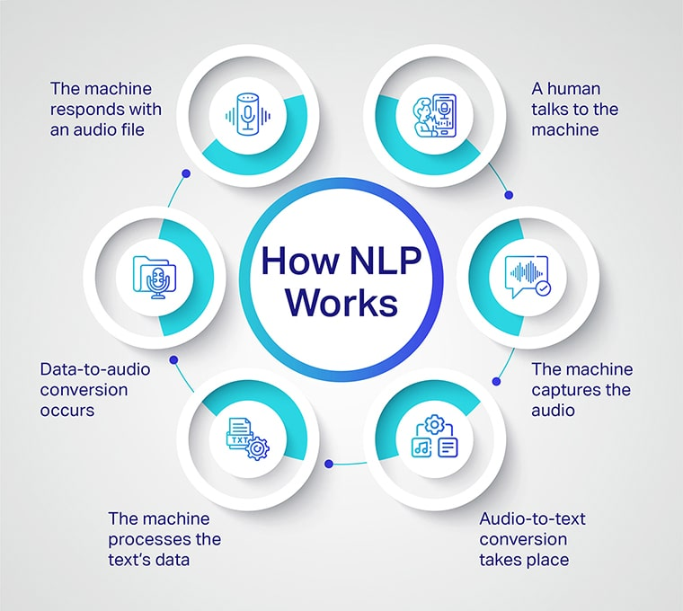

**Figure 3.1. Working of NLP in voice process**

Natural Language Processing involves four key steps:

1. Alexa initially records your speech, as interpreting sounds requires significant computational power. Your voice input is then sent to Amazon's servers for processing and interpretation. [9]
2. Next, Alexa parses or breaks down the interpreted audio input into individual sounds. It then consults an audio database containing various word pronunciations to find the closest corresponding matches to the segmented audio input. [9]
3. After this, Alexa identifies keywords contained in the now recognized audio input and executes the corresponding functions required to fulfil- the command or request. For example, if you say to Alexa, "Alexa, what is the weather like today?" after recording, interpreting, breaking down, and matching your audio input, Alexa recognizes that you are asking about the weather. It then sends this request to Amazon's servers, which make an API request to a weather service API to provide the requested information. [9]
4. After the request is processed and information is retrieved, Amazon's servers send this information back to the device. Alexa then formulates a response by converting the retrieved information into speech using natural language generation. This response is then spoken back to the user, completing the interaction. [9]

**3.2 Natural Language Understanding**

NLU, or Natural Language Understanding, is a subset of NLP (Natural Language Processing) and a crucial initial step in interpreting human natural language. It falls under the umbrella of Artificial Intelligence, focusing on the comprehension of various human languages by computational algorithms. Understanding a language, which might be different from person to person, presents a challenge compounded by the complex structure of sentences. Sentences can be constructed in numerous ways, with words arranged in different orders, whether spoken or written. [10]

Computational power is essential for extracting meaningful words from sentences and passing them to further processing logic (NLP) to generate appropriate responses to user requests. This necessitates robust server scaling, typically facilitated through cloud computing, a capability effectively leveraged by Amazon. NLU also plays a critical role in understanding sentence context, identifying components such as verbs, nouns, and tenses. This linguistic analysis is known as "Part of Speech Tagging" (POS). [10]

**3.3 Deep learning**

Deep learning a subset of machine learning, focuses on training models that specialize in tasks like acoustic modelling, which involves pairing audio inputs with their corresponding transcripts. This process is analogous to how the brain of human functions, where neurons enable decision-making. In deep learning technology, Artificial Neural Networks form a complex web akin to the brain's neural connections. [11]

The data processed in deep learning is typically vast and unstructured. Unlike traditional linear methods, deep learning allows machines to process this data in a non-linear fashion, uncovering intricate patterns and relationships. As a continuously evolving field, deep learning attracts significant investment and research from numerous companies seeking to enhance its capabilities. [11]

**3.4 Alexa Architecture**

Alexa, which is a cloud-based service from Amazon, has the following components:

* **Echo device:**

An Echo device is built to accept user instructions via voice commands. [11]

* **Signal processing**:

Signal processing with Echo devices involves filtering and enhancing audio signals to correctly capture voice commands amidst background noise. This is accomplished by employing methods such as beamforming, which uses multiple microphones to concentrate on the user's voice while minimizing other ambient sounds such as music or TV noise. Acoustic echo cancellation further reduces unwanted signals, ensuring that only the user's voice is processed for accurate recognition and command execution. These methods serve as essential for improving speech interactions with Echo devices in a variety of settings in terms of dependability and efficacy. [11]

* **Alexa Voice Service:**

In the Alexa Voice Service, services are referred to as Alexa skills. Depending on the voice command issued by the user, the appropriate skill is invoked to provide a meaningful response. Getting specialized knowledge is necessary to build Alexa skills so that you can apply practical solutions that meet user expectations. Skills are essential in interpreting user inputs, processing them, and delivering relevant responses based on the invocation name and utterance in the spoken sentence. The utterance represents the specific phrase expressing the user's intended action or query, guiding Alexa to understand and fulfil the user's request accurately. [11]

* **Alexa Skills:** The Alexa Skills Kit (ASK) is a development framework that enables you to generate custom content, known as skills, for Alexa. These skills function similarly to apps, providing an interactive voice interface that enables users to engage with your skill hands-free. By voice commands, peoples can accomplish a range of tasks, including checking the news, playing music, or playing games. Additionally, users can manage cloud-connected devices, like asking Alexa to turn on lights or adjust the thermostat. Skills can be obtained on Alexa-enabled devices, such as Amazon Echo and Amazon Fire TV, as well as on Alexa-compatible devices from other manufacturers. [11]
* **Device cloud:**

This component receives inputs from Alexa Voice Service, which provides responses based on the user's input. It then sends command signals to an appropriate device connected online through a device cloud to execute the instructed action. for example, turning on an air conditioner or turn on a TV, through the user's commands received and processed by Alexa. [11]

**Client**  **Server**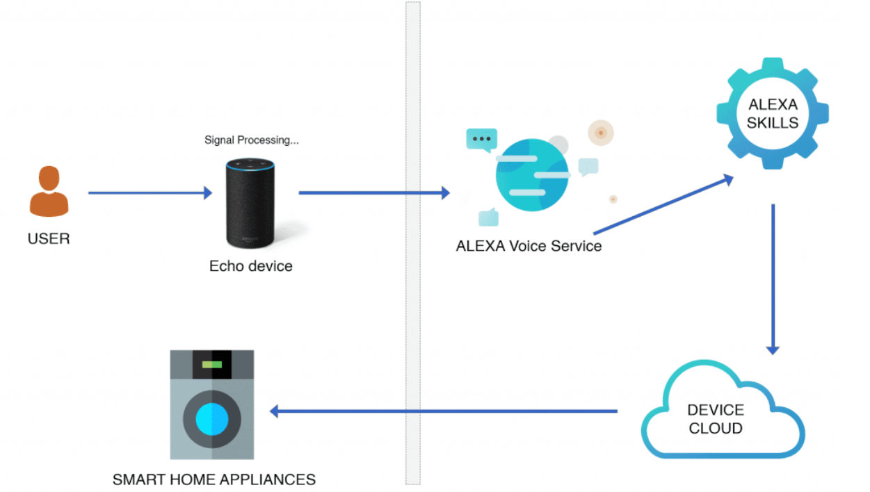

**Figure 3.4. Alexa Architecture**

**3.5 System Architecture**

The block diagram illustrates the working process. The 230 V supply is first rectified and filtered to power the relay. The Echo Dot remains always on, waiting for the wake word. When a voice command is given, it is processed through the Alexa cloud server, which uses the Alexa Voice Service for voice recognition. The processed commands from the cloud are sent to the NodeMCU(ESP8266), which then activates the appropriate relay based on the command. Each device or appliances is assigned a name in the ESP8266 programming. When a command is received, it is recognized by the registered server through the internet, ensuring the correct relay is activated. By measuring the moisture content in the soil, we can determine if a plant is optimally watered, overwatered, or under watered. Sensors of soil moisture are employed to continuously monitor the garden's moisture levels. This information is then transmitted to the Thingspeak app for real-time tracking and adjustments. [4]

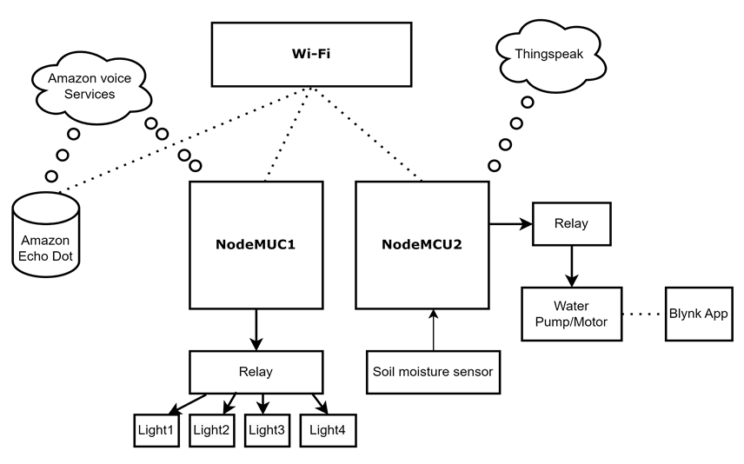

**Figure 3.5. System Architecture of Smart Home**

**3.6 Data Flow Diagram**

**3.6.1 Data Flow Diagram Level 0**

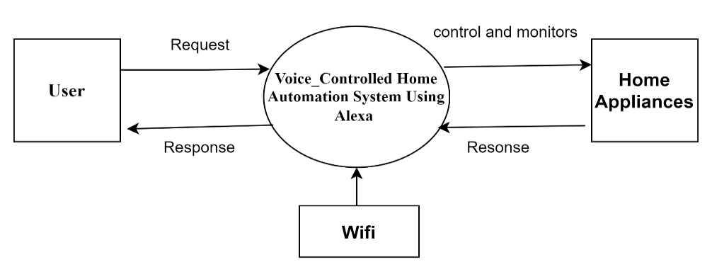

**Figure** **3.6.1. Data Flow Diagram Level-0**

This diagram represents the flow of commands received by Alexa, distinguishing between commands related to home automation (e.g., turning on lights, adjusting thermostat, locking doors) and commands related to garden monitoring (e.g., watering plants, checking soil moisture). It includes error handling for unrecognized commands. Adjust the conditions and actions as per your specific home automation and garden monitoring setup. [4]

**3.6.2 Data Flow Diagram Level 1**

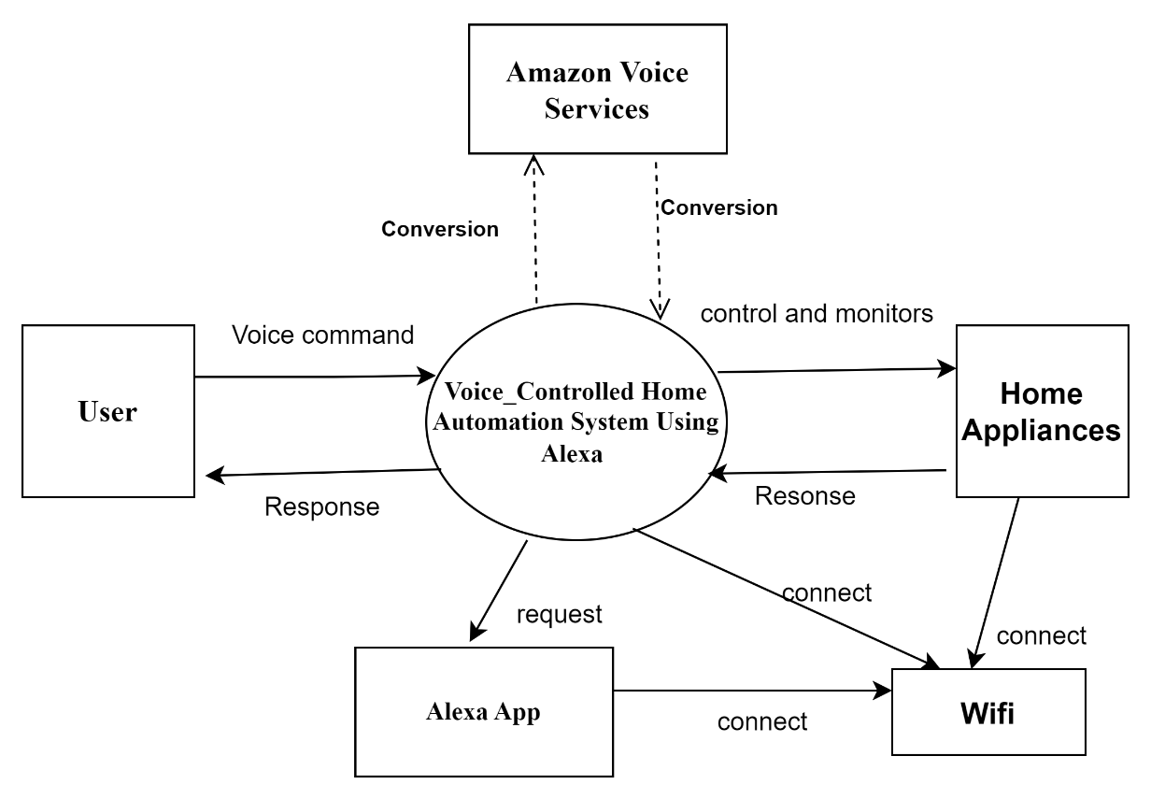

**Figure 3.6.2. Data Flow Diagram Level-1**

The above diagram illustrates how DFD1 works. The Level 0 DFD is expanded into a Level 1 DFD for greater detail. This gives more detailed diagram of how the flow of data and commands among the user, Alexa device, home automation hub, smart devices, and the garden monitoring system, and how these components interact with each other. [4]

**3.7 USECASE DIAGRAM**

The below figure illustrates the key functionalities or use cases of a home automation system, including controlling lights and interacting through voice commands via Alexa.

* The actors are "User," "Alexa," and "Sensor."
* The "Home Automation System" and "Garden Monitoring System" are depicted as rectangles containing respective use cases.
* Use cases include controlling lights, adjusting temperature, managing the security system, monitoring soil moisture, and watering plants.

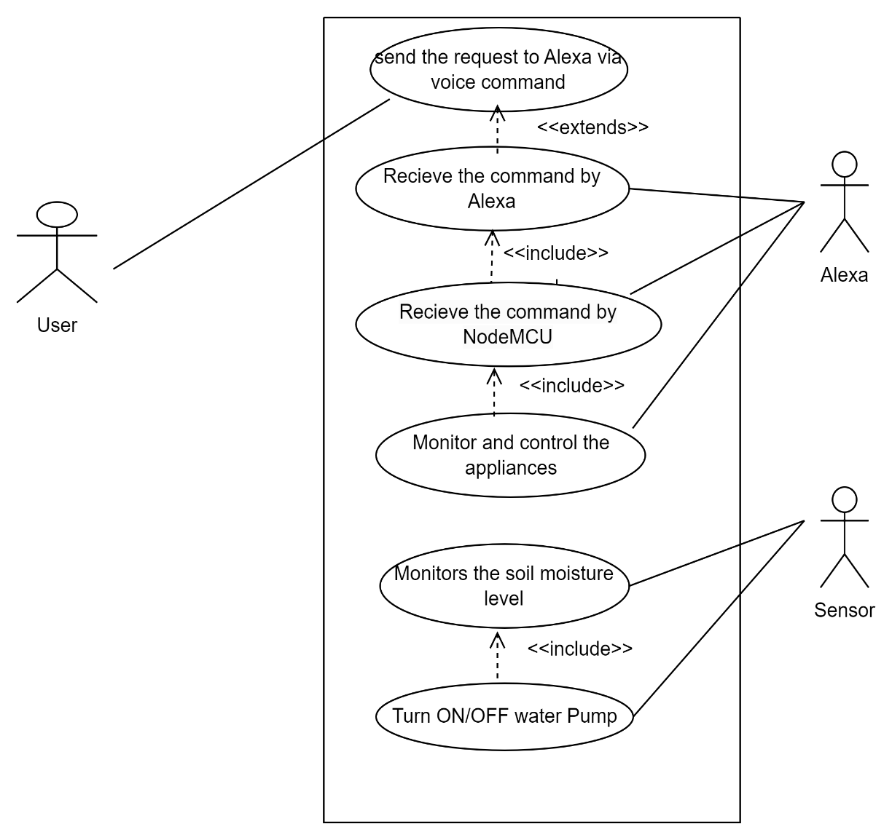

**Figure 3.7. Use case diagram**

**3.8 SEQUENCE DIAGRAM**

This sequence diagram depicts the flow of information between the user, Alexa, the home automation system, and the garden monitoring system. [4]

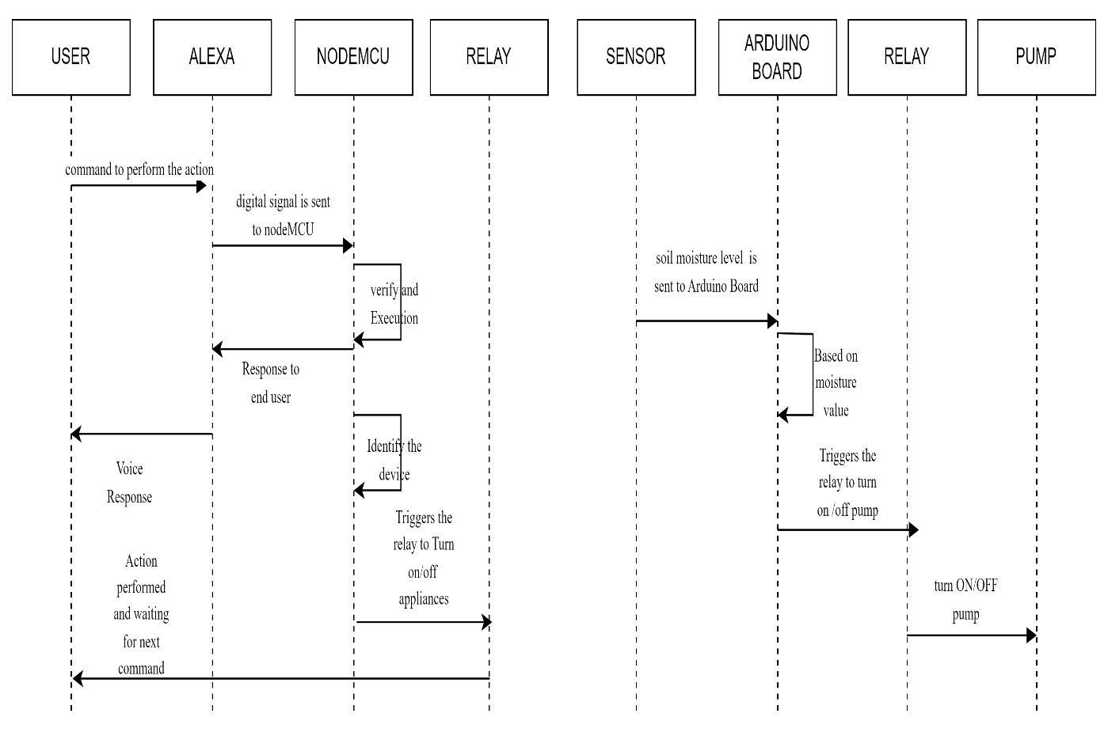

**Figure 3.8. Sequence Diagram**

**3.9 ACTIVITY DIAGRAM**

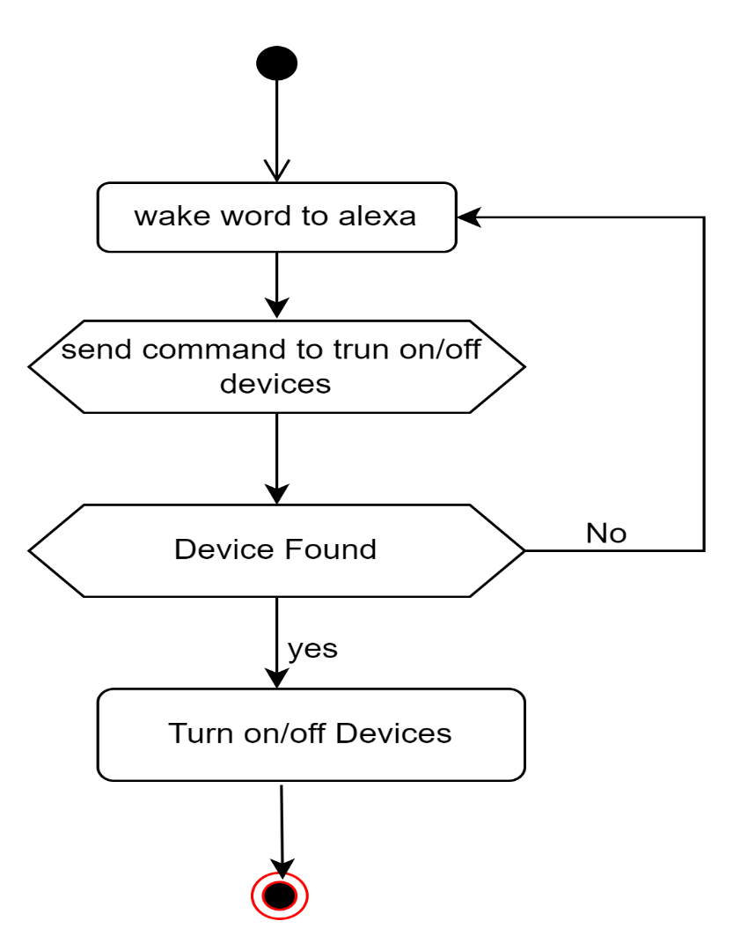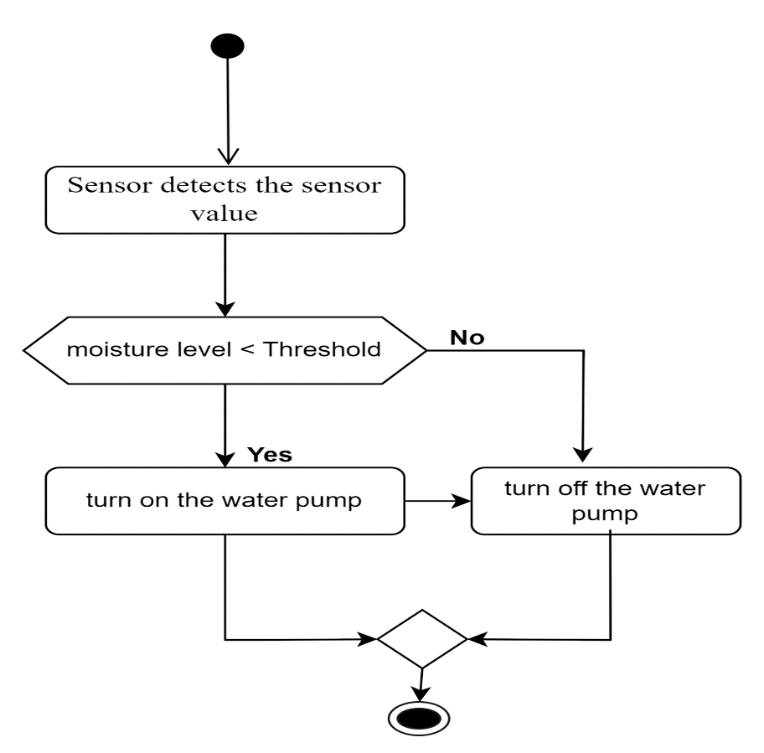

**Figure 3.9 Activity Diagram**

This diagram shows the flow of commands received by Alexa, distinguishing between commands related to home automation (e.g., turning on lights, turning on fan, locking doors) and automatic garden monitoring (e.g., watering plants, checking soil moisture). It includes adjust the conditions and actions as per your specific home automation and garden monitoring setup. [4]

**3.10 CLASS DIAGRAM**

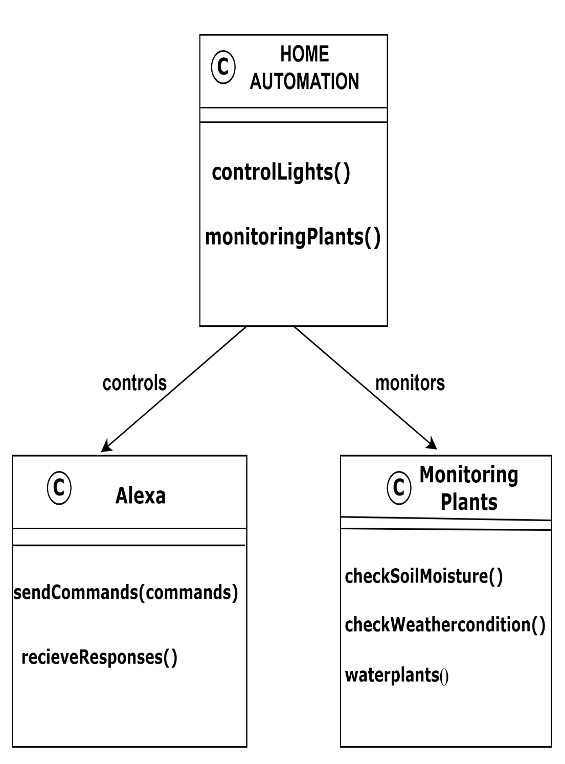

**Figure 3.10 Class Diagram**

This diagram illustrates the basic classes involved in a project with Alexa integration and garden monitoring. The Home Automation system class has methods to control various aspects of the home, including lights, temperature, security, and garden monitoring. The Alexa class represents the voice assistant with methods to activate/deactivate skills, send commands, and receive responses. The Garden Monitor class is responsible for checking soil moisture, weather conditions, and watering plants in the garden. [4]

**CHAPTER 4**

**IMPLIMENTATION**

The Several smart devices must be integrated to construct a home automation system, sensors, and controllers to enable automated and remote control of household functions. This process enhances convenience, security, energy efficiency, and overall quality of life. Here are the key steps involved in implementing a home automation system.

You may effectively install a smart home system that enhances your home's functionality, security, and convenience to use by following these instructions. [12]

* Assess Your Needs: Determine what aspects of home automation are most important to you (e.g., security, energy efficiency, convenience).
* Research and Choose Devices: Look into gadgets that fit your needs and make sure the ecosystem you have selected is compatible with them (e.g., Alexa, Google Home, etc.).
* Set Up Your Network: Ensure your home network is robust and secure, offers adequate coverage in every location where your smart devices are used.
* Install Devices: Start with a few key devices, install them according to the manufacturer’s instructions, and ensure they are working correctly.
* Configure and Integrate: Use your central hub or smart home app to configure settings and create automation routines (e.g., turning lights on/off based on time or motion detection).
* Test and Optimize: Regularly test your devices and automation routines to ensure they are working as expected and make adjustments as needed.

**4.1 Equipment’s required for Smart Home**

* ESP module 8266
* Relay
* Jump wires
* DHT sensor
* Soil Moisture sensor
* Amazon Echo dot

**4.1.1 ESP Module 8266**

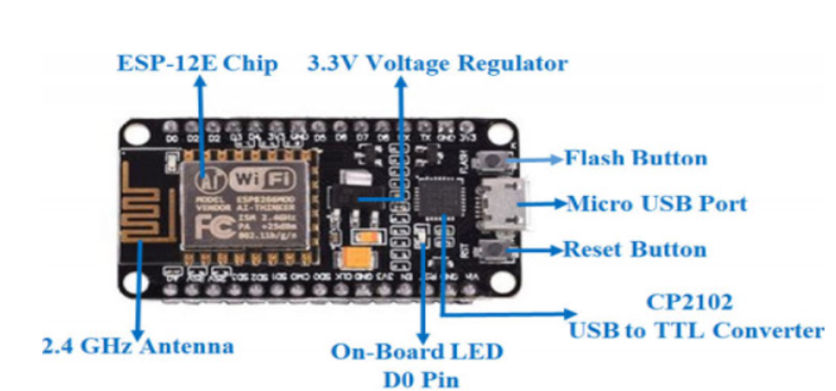

**Figure 4.1.1. ESP8266(NodeMCU)**

The low-cost ESP8266 System-on-a-Chip serves as the foundation for the open-source development platform known as NodeMCU (Node Microcontroller Unit), designed by Espressif Systems. The ESP8266 integrates essential computer components, including a CPU, RAM, Wi-Fi networking, and a modern operating system with an SDK, making it ideal for various Internet of Things (IoT) projects. [12]

**4.1.2 Amazon Echo Dot**

Alexa is Amazon's cloud-based voice service, accessible on hundreds of millions of devices from both Amazon and third-party manufacturers. By leveraging Alexa, you can create natural voice experiences that provide customers with a more intuitive method of interacting with everyday technology. Amazon offers a comprehensive collection of tools, APIs, reference solutions, and documentation to simplify the development process for Alexa. [12]

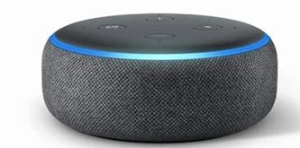

**Figure 4.1.2. Amazon Echo Dot**

**4.1.3 Breadboard**

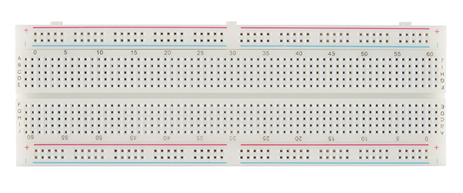

**Figure 4.1.3. Breadboard**

A breadboard, sometimes referred to as a plug block, is a tool used for building temporary circuits. It is especially valuable to designers because it allows for easy removal and replacement of components. It is, therefore, ideal for those who want to build a circuit to demonstrate its functionality and then reuse the components in another circuit. The breadboard is made up of a plastic block containing a matrix of electrical sockets that can grip thin connecting wires, component leads, or the pins of transistors and integrated circuits (ICs). Inside the board, the sockets are usually connected in rows of five. These rows are spaced 2.54 mm apart, and the sockets in each row are also 2.54 mm apart, which is the standard spacing for IC pins and many other electronic components. In the upper right corner of the picture is a row of five connected sockets. [12]

**4.1.4 4-Channel Relay Module**

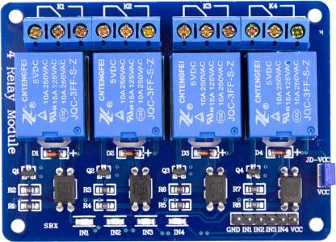

**Figure 4.1.4. 4-Channel Relay Module**

A 4-Channel Relay Module is an electronic component that allows you to control four independent electrical circuits via a microcontroller or similar control system. It is commonly used in a range of projects and applications, including home automation, industrial automation, and robotics, to safely manage devices such as lights, motors, and other high-power circuits. [12]

**4.1.5 Jumper Wires**

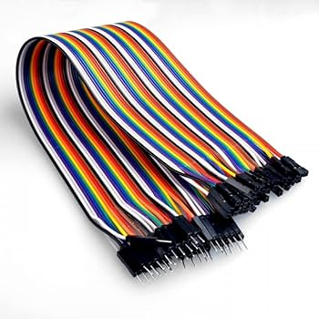

**Figure 4.1.5. Jumper Wires**

Dupont cables, also known as jumper wire cables, are low-cost and versatile connectors used to link various hardware components such as sensors, Arduino boards, and breadboards. These cables are essential for prototyping and testing circuits since they enable fast and easy connections without the any soldering. [12]

**4.1.6 Soil Moisture Sensor**

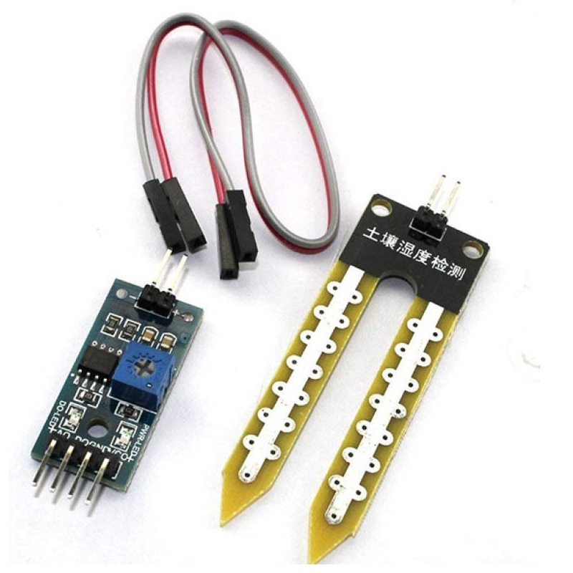

**Figure 4.1.6. Soil Moisture sensor**

The quantity of water in the soil is measured or estimated by soil moisture sensors. These might be handheld probes or they can be stationary. For continuous monitoring, stationary sensors are positioned at specific depths and places within a field, while portable probes measure soil moisture at several sites, providing flexibility in assessment across 43 different areas.[12]

* 1. **Circuit Diagram**

**4.2.1 Circuit Diagram of Home Automation**

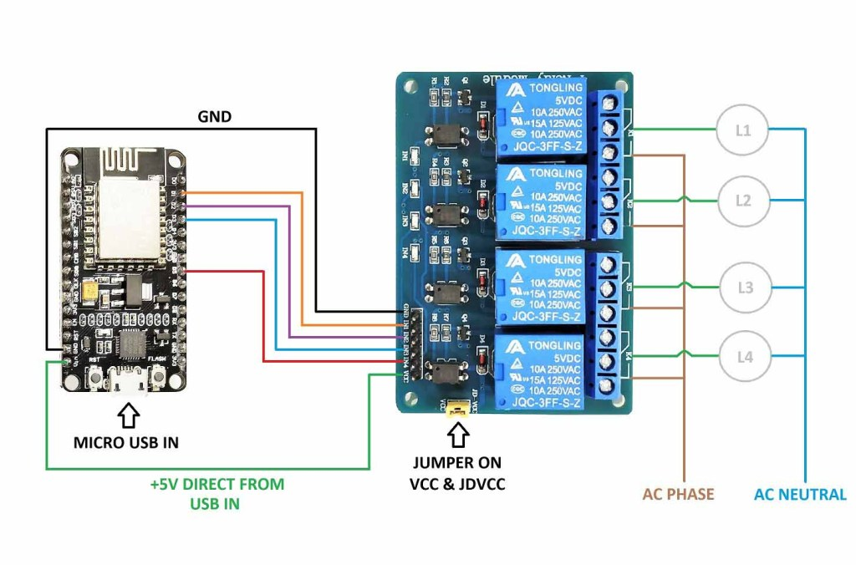

**Figure 4.2.1 Circuit Diagram of Home Automation**

**4.2.2 Circuit Diagram of watering the plants**

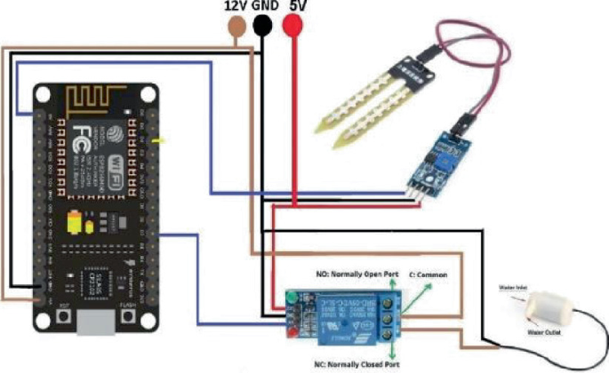

**Figure 4.2.1 Circuit Diagram of watering the plants automatically**

**4.3 ESP8266 NodeMCU Pinout**

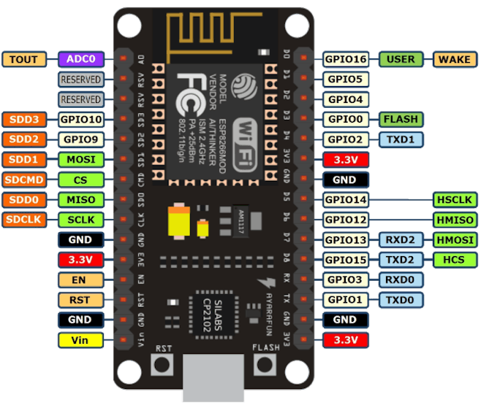

**Figure 4.3. The ESP8266 NodeMCU Pinout**

**4.3.1 Pinout Configuration of NodeMCU Development Board**

|  |  |  |
| --- | --- | --- |
| **Pin Type** | **Name** | **Description** |
| Power | Micro-USB, 3.3V, GND, Vin | Micro-USB:  The NodeMCU can be powered via the USB port.  3.3V:  This pin can be supplied with a regulated 3.3V to power the board.  GND: Ground pins  Vin: External power supply input |
| Control Pins | EN, RST | The reset button in the microcontroller. |
| Analog Pin | A0 | measures analog voltage within the range of 0-3.3V. |
| GPIO Pins | GPIO1 to GPIO16 | NodeMCU features 16 general-purpose input/output (GPIO) pins on its board. |
| SPI Pins | SD1, CMD, SD0, CLK | NodeMCU provides 4 pins for SPI communication. |
| UART Pins | TXD0, RXD0, TXD2, RXD2 | NodeMCU features two UART interfaces: UART0 (RXD0 & TXD0) and UART1 (RXD1 & TXD1). UART1 is specifically used for uploading firmware and programs. |
| I2C Pins |  | NodeMCU supports I2C functionality, but because of the internal configurations of its pins, you need to identify which pins are assigned for I2C communication. |

**CHAPTER 5**

**TESTING**

**5.1 UNIT TESTING**

The Unit testing contains thoroughly examining a specific component, focusing solely on that individual unit. While this may involve testing multiple functions, it's sometimes unclear which device should be tested. The decision on the type of testing to conduct is typically made by the structure and development team. Functional testing, a term used to describe this approach, emphasizes the evaluation of the system's input and output activities. This type of testing often involves assessing units within predefined boundaries. Additionally, a scaffold, in the industrial sector, refers to a simple, temporary structure used to support workers. [3]

A scaffold is constructed using one or more flexible hardwood planks of varying lengths and widths, with its support structure varying based on the load, purpose, assembly, and disassembly needs of the building. Before the actual construction begins, the erection teams, who are the construction workers, first set up the scaffolding. Once the foundation boards are removed, the entire structure becomes visible. Similarly, only minimal software support is required for a single, specific test. [3]

The program facilitates the creation of a dependable test evaluation. Scaffolding software—any code written outside the main program—is commonly developed to aid in unit and integration testing. The use of this technology may be necessary, and the approach can vary depending on the specific test. This type of software does not concentrate on the individual components of a specific system.[3]

This type of software can sometimes become more complex than both the application software that users rely on for their personal tasks and the computer programs that manage hardware. For example, when a user issues a voice command to an Alexa device, the command is sent to Amazon Voice Service, which converts the speech to text. This text is then sent to a microcontroller, which signals a relay module to activate specific appliances [3]

**5.2 INTEGRATION TESTING**

Integration testing can generally be categorized into top-down or bottom-up approaches. In the top-down method, intermediate-level control structures are replaced with stubs to focus on evaluating the high-level control procedures first. Within the top-down approach, you can still apply depth-first or breadth-first ordering strategies. [3]

During depth-first integration testing, each module is tested individually by progressively replacing stubs with detailed code, often addressing multiple layers of functionality in a single step. In contrast, breadth-first integration testing involves maintaining a consistent level of control across all modules, ensuring that each module is equally tested throughout the implementation process. Initially, each module may only be partially functional and designed to handle incorrect data. In this approach, both breadth-first and depth-first testing are conducted in parallel to thoroughly evaluate the entire system. [3]

The bottom-up method of integration testing involves evaluating individual modules to develop a test harness for each one. After testing a module, it is combined with other modules to create builds, which are then tested using a new harness. This process continues with additional testing until the entire application is included in the build. The procedure is repeated at each stage to ensure thorough integration testing. [3]

A common practice in integration testing is to combine both top-down and bottom-up methodologies. Teams or individuals might use the bottom-up approach for their integration testing, but they must complete their testing before passing the results to an integration team. This team then consolidates the results for the top-down approach. [3]

* 1. **VALIDATION AND SYSTEM TESTING**

During integration testing, validation testing becomes a key concern. Ensuring that all activities required to meet the integration test's requirements have been completed is essential. Validation testing has a broader scope compared to system testing, which focuses on the implementation within its natural environment. This overlap creates uncertainty in how to distribute efforts between system testing and validation. Consequently, due to the extensive range of tasks involved, the distinction between validation and system testing can be blurred, and both types of testing can be conducted simultaneously. System testing is a comprehensive phase in the software development lifecycle where the entire system is evaluated to ensure it meets specified requirements and functions correctly in a real-world environment [3]

* Performance testing measures the speed, average load time, stability, reliability, and peak response times of the system under various conditions. It is typically combined with stress testing and may involve both hardware and software testing tools.
* Usability testing evaluates whether a system is user-friendly and functional for the end user. Metrics such as user error rates, task success rates, the time it takes a user to complete a task, and user satisfaction are used during this testing.
* Load testing determines how a system or software performs under extreme real-life load scenarios. Metrics such as throughput, number of users, and latency are measured through this testing.
* Regression testing, also known as sanity testing, ensures that recent changes or updates to an application or code have not introduced any new bugs or issues. It is responsible for validating the functionality of existing features of a system or software.
* Migration testing ensures the smooth migration of legacy systems to new systems without disruptions, data loss, or downtimes.
* Scalability testing measures an application's or system's ability to scale up or down to meet changing user requirements.
* Functionality testing validates a system's functionality against its functional and business requirements.
* Recovery testing is a type of nonfunctional testing that ensures a system can recover from certain errors, crashes, and failures.

System testing is crucial for delivering a high-quality, reliable, and user-friendly system. By thoroughly evaluating the integrated system, organizations can ensure that it meets user needs, performs effectively, and is ready for successful deployment. Once the implementation changes are completed during the alpha phase, the software can be made available to numerous select customers. Ultimately, a software inspection is conducted to ensure that the entire software project is thoroughly examined to meet implementation management requirements. This ensures that all necessary documentation is created in the correct format and is of satisfactory quality. [3]

**5.4 Test Cases**

**Table 5.4.1. Device setup**

|  |  |  |  |  |  |
| --- | --- | --- | --- | --- | --- |
| **Test case No** | **Test Objective** | **Input** | **Expected output** | **Actual output** | **Pass**  **/Fail** |
| Tc1 | Setup Alexa Device | Download Alexa app and discover the device | Device Configured | Device Configured | Pass |
| Tc2 | Unable to Setup Alexa Device | Unable to download Alexa app and not discovered the device | Device not  configured | Device not  configured | Fail |

**Table 5.4.2. Connecting Circuit to Wi-Fi**

|  |  |  |  |  |  |
| --- | --- | --- | --- | --- | --- |
| **Test case No** | **Test Objective** | **Input** | **Expected output** | **Actual output** | **Pass**  **/Fail** |
| Tc1 | Setup NodeMCU to Wi-Fi | Give same credentials of Wi-Fi network in code | Compiled and uploaded code | Wi-Fi connected | Pass |
| Tc2 | Unable to Setup NodeMCU to Wi-Fi | Given credentials is not matching | Code not Compiled and uploaded | Wi-Fi not connected | Fail |

**Table 5.4.3. Check the Kitchen Light ON/OFF**

|  |  |  |  |  |  |
| --- | --- | --- | --- | --- | --- |
| **Test case No** | **Test Objective** | **Input** | **Expected output** | **Actual output** | **Pass/Fail** |
| Tc1 | Check the kitchen light | Command is given from user to ON/OFF kitchen light | ON/OFF the kitchen light | Display kitchen light on/off | Pass |
| Tc2 | Unable to on/off kitchen light | If command and device not discovered | Unable to ON/OFF the kitchen light | Unable to display light | Fail |

**Table 5.4.4. Check the Study Light ON/OFF**

|  |  |  |  |  |  |
| --- | --- | --- | --- | --- | --- |
| **Test case No** | **Test Objective** | **Input** | **Expected output** | **Actual output** | **Pass/Fail** |
| Tc1 | Check study light | Command is given from user to ON/OFF study light | ON/OFF the study light | Display study light on/off | Pass |
| Tc2 | Unable to on/off study light | If command and device not discovered | Unable to ON/OFF the study light | Unable to display light | Fail |

**Table 5.4.5. Check the Bedroom Light ON/OFF**

|  |  |  |  |  |  |
| --- | --- | --- | --- | --- | --- |
| **Test case No** | **Test Objective** | **Input** | **Expected output** | **Actual output** | **Pass/Fail** |
| Tc1 | Check Bedroom light | Command is given from user to ON/OFF bedroom light | ON/OFF the Bed Room light | Display Bedroom light on/off | Pass |
| Tc2 | Unable to on/off bedroom light | If command and device not discovered | Unable to ON/OFF the bedroom light | Unable to display light | Fail |

**Table 5.4.6. Check the All the Lights ON/OFF**

|  |  |  |  |  |  |
| --- | --- | --- | --- | --- | --- |
| **Test case No** | **Test Objective** | **Input** | **Expected output** | **Actual output** | **Pass/Fail** |
| Tc1 | Check all light | Command is given from user to ON/OFF all light | ON/OFF the all light | Display all light on/off | Pass |
| Tc2 | Check all light | If command and device not discovered | ON/OFF the all light | Cannot display any light | Fail |

**Table 5.4.7 Check the Water pump/Motor ON/OFF**

|  |  |  |  |  |  |
| --- | --- | --- | --- | --- | --- |
| **Test case No** | **Test Objective** | **Input** | **Expected output** | **Actual output** | **Pass**  **/Fail** |
| Tc1 | Check water pump/motor on | soil moisture value is less than the threshold | Turn On the water Pump/motor | Turn On the water Pump/motor | Pass |
| Tc2 | Check water pump/motor off | Unable to read soil moisture or threshold is greater than soil moisture value | Turn off the water Pump/motor | Turn off the water Pump/motor | Fail |

**CHAPTER 6**

**RESULTS**

Alexa-based smart home systems offer a more user-friendly, flexible, and cost-effective solution compared to traditional home automation systems. They provide ease of setup, wide compatibility, and advanced features through voice control and app integration. Smart garden monitoring system, ensuring efficient and effective garden management. [11]

**6.1 Switching ON/OFF Lights using Alexa**

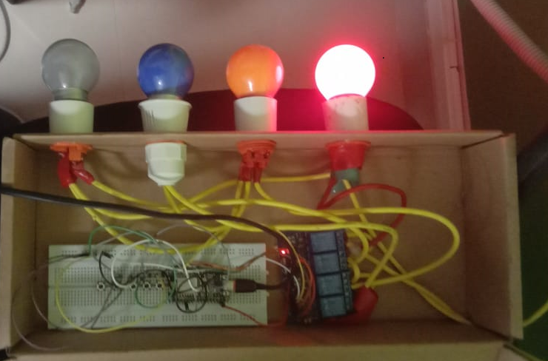**Figure 6.1.1. Switch on the Kitchen light**

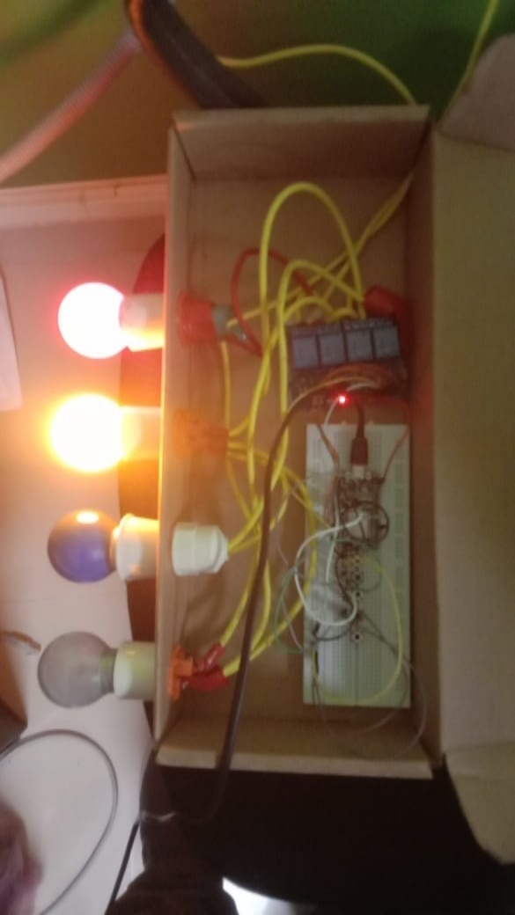 **Figure 6.1.2. Switch on the Study light**

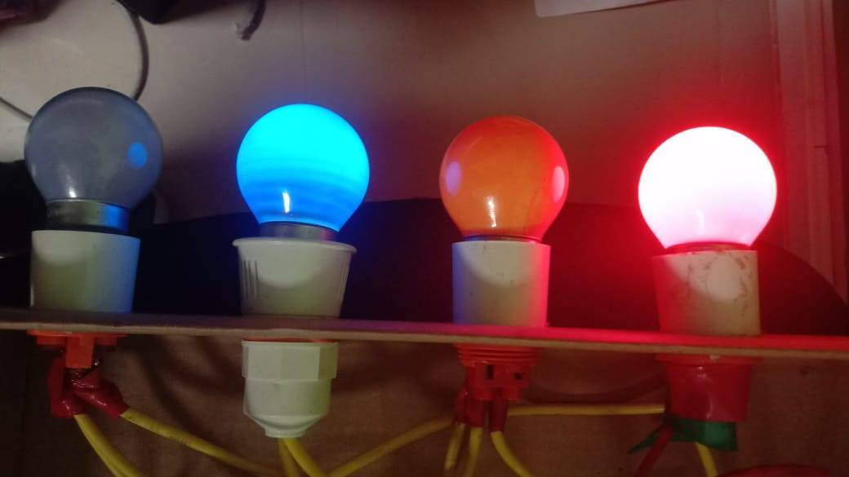

**Figure 6.1.3. Switch on the Bedroom light**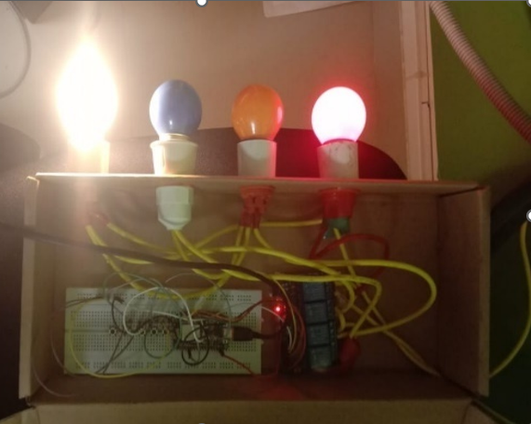

**Figure 6.1.4. Switch on the living room light**

**6.2 Watering the garden plants**

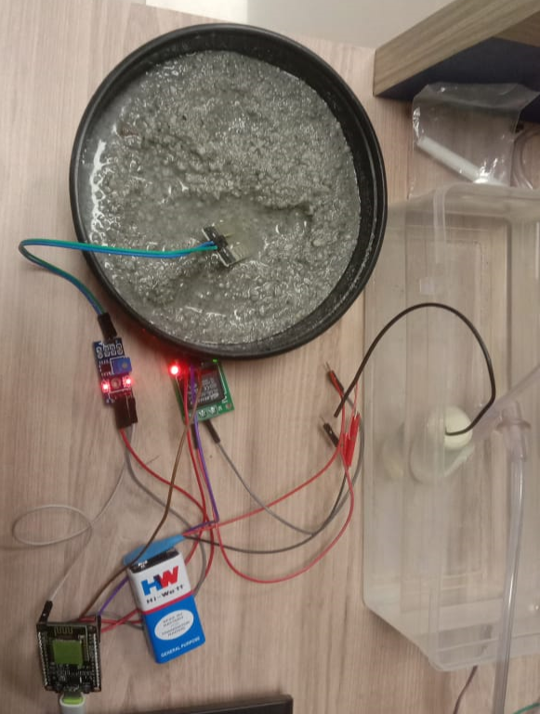

**Figure 6.2.1. Turn ON/OFF motor based on soil Moisture level**

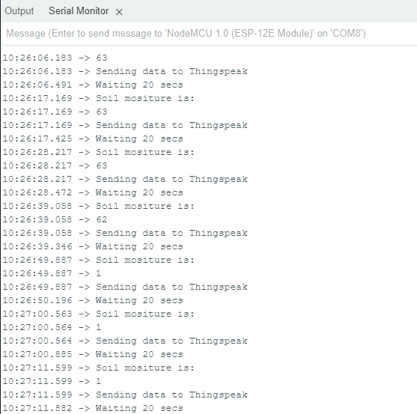

**Figure 6.2.2. Monitoring the soil moisture level in Serial Monitor**



**Figure 6.2.3. Turn ON/OFF motor or water pump using Blynk app**

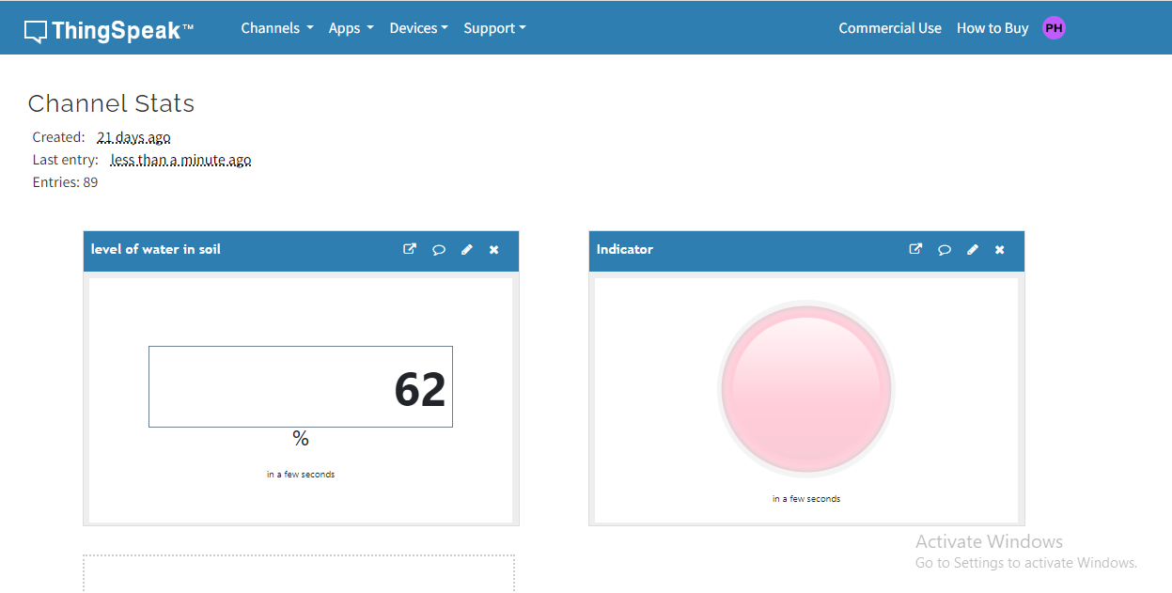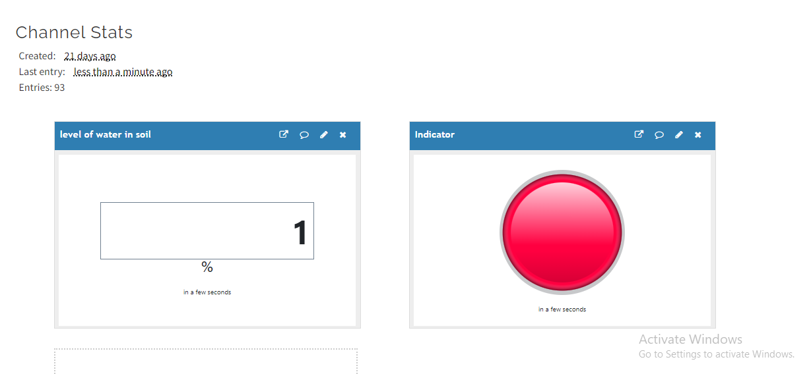**Figure 6.2.4 Measuring Moisture level using Thingspeak**

**CONCLUSION**

An Alexa-based home automation system that utilizes NodeMCU offers an efficient and convenient method for controlling various devices and appliances in your home. By combining NodeMCU, an open-source IoT platform, with the voice-controlled virtual assistant Alexa, you can achieve seamless automation and control through voice commands. The system's architecture involves connecting NodeMCU to your home Wi-Fi network, which enables it to communicate with the Alexa cloud service. This setup allows you to use voice commands with Alexa to remotely control the connected devices in your home. Incorporating Amazon Alexa as a voice-controlled virtual assistant into a home automation system has greatly enhanced the smart home experience. The system's design and implementation demonstrate strong performance, comprehensive functionality, high user satisfaction, and a distinct edge over traditional control methods. The voice-activated home automation system utilizing Amazon Alexa allows users to effortlessly control various devices and appliances using voice commands, eliminating the need for manual interactions or navigating through complex mobile applications. This offers a more intuitive and convenient control method. The hands-free nature of voice commands enhances accessibility and usability, making it especially advantageous for people with mobility impairments. The integration of the system with Amazon Alexa demonstrates the significant potential of voice control to improve the usability, convenience, and efficiency of smart homes. It provides a user-friendly interface, customizable voice commands, and the capability to create routines, allowing users to tailor their home automation experience to their preferences and daily activities. With this setup, tasks such as turning lights on and off, adjusting thermostats, controlling smart plugs, and managing security systems can all be automated through voice control. NodeMCU serves as a bridge between the Alexa cloud service and physical devices, leveraging its capabilities to operate with different actuators and sensors. The implementation of a plant watering system using NodeMCU, ESP8266, and a soil moisture sensor effectively addresses the challenges of maintaining soil moisture levels for plant health. By leveraging the capabilities of NodeMCU and ESP8266 for wireless connectivity, combined with the real-time data from the soil moisture sensor, the system ensures precise and automated watering. This solution not only reduces manual effort but also optimizes water usage, promoting healthier plant growth and contributing to resource conservation. The integration of these technologies demonstrates a practical application of IoT in home gardening, offering a reliable and efficient method for plant care that can be easily scaled and customized for various needs. This enables local users and gardeners to care for their plants more effectively. Key environmental factors monitored include soil temperature, moisture, and relative humidity. The results are displayed on Thingspeak, which is integrated into the device, and are also accessible via a mobile application.

**FUTURE ENHANCEMENT**

In the future, we plan to extend this work to include many more devices in the home to achieve complete home automation. Additionally, we intend to incorporate LoRa technology for applications in smart farming. This includes deploying a smart garden monitoring system using LoRa (Long Range) technology can provide significant enhancements over traditional methods. LoRa offers long-range communication, low power consumption, and the ability to connect multiple sensors across a wide area, making it ideal for garden and agricultural monitoring. By incorporating LoRa technology, you can significantly enhance the capabilities and range of smart garden monitoring system, ensuring efficient and effective garden management.

# **REFERENCES**

[1] S Anjali Devi, M. Sitha Ram, Katakam Ranga Narayana, D. Babu Rao, Venubabu Rachapudi, ‘Smart Home system Using Voice Command with Integration of ESP8266’: - ***2022 International Conference on Applied Artificial Intelligence and Computing (ICAAIC. 978-1-6654-9710-7/22/$31.00 ©2022 IEEE - DOI: 10.1109/53929.2022.9793317.***

[2] Ajmera Kiran, G. R. Sakthidharan, ‘Voice Controlled Home Automation System using Google Assistants ‘, ***International Conference on Computer Communication and Informatics (ICCCI), 2023 doi: 10.1109/ICCCI56745.2023.10128217***

[3] “Voice-Activated wireless Control System for home automation Using 2.4GHZ WiFi”, -2022, K Rajkumar, Sugunesh R, Risheka S, M. G Suwathi,2022, **‘International conference on power, Energy, Control and Transmission Systems’ (ICPECTS)- 978-1-6654-6275-4/22/$31.00 ©2022 IEEE | DOI: 10.1109/ICPECTS56089.2022.10046931.**

[4] Ashwin Yadav, Pankaj Khute,-” Home Automation System In Main Switch Bord”, ***International Research Journal of Modernization in Engineering Technology and Science(IRJMETS)-2024,Volume:06/Issue:01*** [***doi.org-10.56726/IRJMETS48017***](https://www.doi.org/10.56726/IRJMETS48017)***.***

[5] Tushar Chaurasia, Prashant Kumar Jain ,”Enhanced Smart Home Automation System based on Internet of Things”***-Proceedings of the Third International Conference on I-SMAC (IoT in Social, Mobile, Analytics and Cloud)-(2019) IEEE Xplore Part Number:CFP19OSV-ART; ISBN:978-1-7281-4365-1***

[6] Ivanshu Patil, Pratham Jiremali,Rohit Mali,Hrushikesh Magar, Sandip A. Kahate-“Home Automation System Using IoT”***-International Journal of Creative Research Thoughts (IJCRT) Volume 11, Issue 6 June 2023 | ISSN: 2320-2882.***

[7] Shradha Somani, Parikshit Solunke, “IoT Based Smart Security and Home Automation”-***2018 fourth International conference on computing communication control and automation (ICCUBEA)- DOI:***[***10.1109/ICCUBEA.2018.8697610***](http://dx.doi.org/10.1109/ICCUBEA.2018.8697610)

[8] Rajakumar. P , K.Suresh , Boobalan M ,IoT-Based Voice Assistant using Raspberry-Pi & Natural Language Processing- ***2022, International Conference on Power Energy Control and Transmission Systems (ICPECTS) - DOI: 10.1109/ICPECTS56089.2022.10046890.***

[9] https://hackernoon.com/ai-for-noobs-how-amazon-alexa-works

[10] <https://towardsdatascience.com/how-amazon-alexa-works-your-guide-to-natural-language-processing-ai-7506004709d3>

[11] <https://www.linkedin.com/pulse/unveiling-magic-natural-language-processing-alexa-swathi-ramya-7revc>

[12] <https://www.electronicsforu.com/electronics-projects/home-automation-alexa>

[13] https://www.techtarget.com/iotagenda/definition/smart-home-or-building